**Forward**

Prof. Hiranmoy Mandal, M.Tech

H.O.D, Department of Electronics &

Instrumentation.

Academy of Technology,

West Bengal.

This is to certify that the project report entitled “**RFID based Attendance Monitoring System**”, submitted to the Department of Applied Electronics and Instrumentation Engineering, Academy of Technology, in partial fulfilment for the award of the degree of Bachelor of Technology in Applied Electronics and Instrumentation Engineering is a record of bonafide work by **Ahana Das** , **Bratati Rout** , **Debapriya Bose**, **Hirak Das**, **Snehasish Malik**, and **Soumalya Sen** under my supervision and guidance.

-----------------------------------

Place: (Prof. Hiranmoy Mandal) Date:31/05/22 Associate Professor, Dept. of AEIE,

Academy of Technology

**Acknowledgement**

We are grateful to our respectable guide, Prof. Hiranmoy Mandal, whose insightful leadership and knowledge benefited us to complete this project successfully. Thank you for your continuous support and presence whenever needed. We would also thank our parents, without their continuous support and guidance, we could not have achieved this. The completion of this project could not have been possible without the participation and assistance of a lot of individuals contributing to this project. However, we would like to express our deep appreciation and indebtedness to our teachers and supervisors for their endless support, kindness, and understanding during the project duration. Last but not the least, we would like to thank everyone who is involved in the project directly or indirectly.

**Contents** Page No.

1. Introduction 4

2. Review of previous works 6

3. Theory 8

4. Design of the Project 13

5. Result/Performance Analysis 20

6. Future work and Conclusion 22

**Figures**

**1. Introduction.**

1.1 RFID based attendance monitoring System 4

**3. Theory.**

3.1 Flowchart of the proposed work 8

3.2 (left to right) Arduino Uno, Arduino Nano, Arduino Ethernet

Shield 9

3.3 I2C 16x2 LCD 10

3.4 LoRa Module (AI-Thinker Ra-02) 10

3.5 RFID-RC522 reader module 11

3.6 Arduino Keypad (3x4) 11

**4. Design of the Project.**

4.1 Flowchart of the complete attendance registering process 12

4.2 Setup of RFID reader with Arduino Uno 14

4.3 Setup of LoRa with Arduino Uno 15

4.4 Interfacing of I2C LCD with Arduino Uno 16

4.5 Student Unit 17

4.6 Master Control Unit 17

4.7 Image depicting the Master Control Unit on the teacher’s dais

(Yellow) and multiple Student Units present at each Desk (Blue). 19

4.8 Complete circuit diagram of the MCU 19

**5. Result/Performance Analysis.**

5.1 LCD displaying the text “Final Year Project” 20

5.2 RFID reader reading the data from the card and transferring that

data to the Uno 20

5.3 One of the SUs sending data to the MCU 21

5.4 Output of MCU receiving data from both the SUs without any loss 21

**Tables**

**4. Design of the Project**

4.1 Component list and their specifications 13

**1. Introduction**

Attendance Management System (AMS) is the easiest way to assist the faculty and the lecturer for this time-consuming process. The most common means of tracking student attendance in the classroom is by enforcing the students to manually sign the attendance sheet, which is normally passed around the classroom while the lecturer is conducting the lecture. For instance, lecturers with a large class may find the hassle of having the attendance sheet being passed around the class and the manual signing of attendance by students are burdensome and most likely distract them from teaching and getting full attention from the students [1].Besides, as the attendance sheet is passed around the class, some students may accidentally or purposely sign another student's name. The first case leads to a student missing out their name, while the latter leads to a false attendance record. Another issue of having the attendance record in a hardcopy form is that a lecturer may lose the attendance sheet [2]. In terms of attendance analysis, the lecturer also has to perform manual computation to obtain the students’ attendance percentage, which normally consumes a lot of time.

[Mario Cardullo](https://en.wikipedia.org/wiki/Mario_Cardullo)'s device, patented on January 23, 1973, was the first true ancestor of modern RFID, as it was a passive radio transponder with memory. The initial device was passive, powered by the interrogating signal, and was demonstrated in 1971 to the New York Port Authority and other potential users. It consisted of a transponder with 16 [bit](https://en.wikipedia.org/wiki/Bit) memory for use as a [toll device](https://en.wikipedia.org/wiki/Electronic_toll_collection). The basic

Cardullo patent covers the use of RF, sound and light as transmission carriers. The original business plan presented to investors in 1969 showed uses in transportation (automotive vehicle identification, automatic toll system, [electronic licence plate](https://en.wikipedia.org/wiki/Electronic_license_plate), electronic manifest, vehicle routing, vehicle performance monitoring), banking (electronic checkbook, electronic credit card), security (personnel identification, automatic gates, surveillance) and medical (identification, patient history).

In 1973, an early demonstration of reflected power (modulated backscatter) RFID tags, both passive and semi-passive, was performed by Steven Depp, Alfred Koelle and Robert Frayman at the [Los Alamos National Laboratory](https://en.wikipedia.org/wiki/Los_Alamos_National_Laboratory). The portable system operated at 915 MHz and used 12-bit tags. This technique is used by the majority of today's UHFID and microwave RFID tags.

In 1983, the first patent to be associated with the abbreviation RFID was granted to [Charles Walton](https://en.wikipedia.org/wiki/Charles_Walton_(inventor)).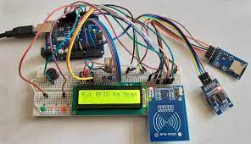

Fig. 1.1: RFID based attendance monitoring system.

Radio-frequency identification (RFID) is a technology that uses radio waves to transfer data from an electronic tag, called RFID tag or label, attached to an object, through a reader for the purpose of identifying and tracking the object. Radio frequency identification (RFID) is a matured technology that incorporates the use of electromagnetic or electrostatic coupling in the radio frequency portion of the electromagnetic spectrum to uniquely identify an object, animal, or person. RFID chips contain a radio transmitter that emits a coded identification number when queried by a reader device. Some RFID tags can be read from several metres away and beyond the line of sight of the reader [3].

The tag's information is stored electronically. The RFID tag includes a small RF transmitter which transmits an encoded radio signal to interrogate the tag, and receiver which receives the message and responds with its identification information. Some RFID tags do not use a battery. Instead, the tag uses the radio energy transmitted by the reader as its energy source. The RFID system design includes a method of discriminating several tags that might be within the range of the RFID reader [3].

LoRa is a proprietary spread spectrum modulation scheme that is derivative of Chirp Spread Spectrum modulation (CSS) and which trades data rate for sensitivity within a fixed channel bandwidth. It implements a variable data rate, utilising orthogonal spreading factors, which allows the system designer to trade data rate for range or power, so as to optimise network performance in a constant bandwidth.

LoRa is a PHY layer implementation and is agnostic with higher-layer implementations. This allows LoRa to coexist and interoperate with existing network architectures. This application note explains some of the basic concepts of LoRa modulation and the advantages that this modulation scheme can provide when deploying both fixed and mobile low-power real-world communications networks [8]

**2. Review of previous works.**

In 2017, authors of [7] used cloud integration and provided SD card storage for backup in case of network failure.

In 2014, authors of [6] designed a similar system where a GSM module would inform the parents in case their wards are absent for the day or are found to have poor attendance over a certain period.

Also in 2012, authors of [5] designed another way of monitoring student and faculty attendance by directly connecting the RFID readers with the network and then storing the information in the server.

In 2012, authors of [3] proposed an additional automatic door that opens upon valid card readings.

In 2009, authors of [4] proposed the idea of RFID based attendance monitoring in institutions/organisations, where any ID card holder may place their card near the reader to seamlessly and efficiently record their attendance.

**Limitations of these models that are addressed in our proposed model are listed below:**

* In all these previous models, a single RFID reader was used to monitor several students.
* Students would need to gather around the reader and wait for their chance to mark their attendance or wait in a queue.
* Models that proposed to monitor the attendance through web browsers only, would require the student to have the necessary infrastructure to view their progress or the faculty to manually make the entry into the database.
* Although replacing manual attendance taking processes with RFID based attendance greatly saves time, using a single reader for even a single class would take a great amount of time considering the fact that each student would take their own time to scan their ID cards on the reader.

**Solutions to these limitations:**

* Each seating is provided with a reader that is low-cost, wirelessly connected, battery operated and power saving. This would not require the students to gather around a single reader to log their attendance.
* The attendance logging process is completely automatic eliminating the need for a teacher/professor to manually log the attendance. Thereby reducing the chances of human induced error.
* Compared with other RFID based attendance systems, our model registers all attendances almost simultaneously which is theoretically even faster than all the previous models listed earlier.

**3. Theory**

The main goal of the system is to detect the presence or absence of any student/employee in an educational institute/organisation [9] simultaneously. RFID technology works mainly with the help of a reader, known as RFID Reader, and RFID cards. The RFID cards have a unique identification number and that is one of the main benefits of the system as this makes the system very reliable. RFID tags are made out of three pieces: a microchip (an integrated circuit which stores and processes information and modulates and demodulates radio-frequency (RF) signals), an antenna for receiving and transmitting the signal and a substrate.

LoRa (from "long range") is a proprietary low-power wide-area network modulation technique. It is based on spread-spectrum modulation techniques derived from chirp spread spectrum (CSS) technology. [18] Designed for IoT communications, LoRa devices enable the connection between remote end nodes and low power wide area networks (LPWANs) for delivery to analytics applications [19].

In all the previous works mentioned earlier, the system had a single RFID reader placed for recording attendance of all students or students of a particular department/year/class. In institutions that require collecting attendance for every lecture, it would be rather more time-consuming for students to gather near the reader and record their attendance. To simultaneously record the attendance of all students present in the class, we are proposing a model where battery powered RFID readers are placed in each student’s desk and are able to record the attendance of all students at once without the student having to get up from their seat. By this means, the time taken for taking attendance would drastically reduce to a few 10s seconds. We are also trying to implement methods that might help in reducing proxy/false attendance. A layout of the work to be done is shown in Fig. 3.1.

3.1 Flowchart of the proposed work:

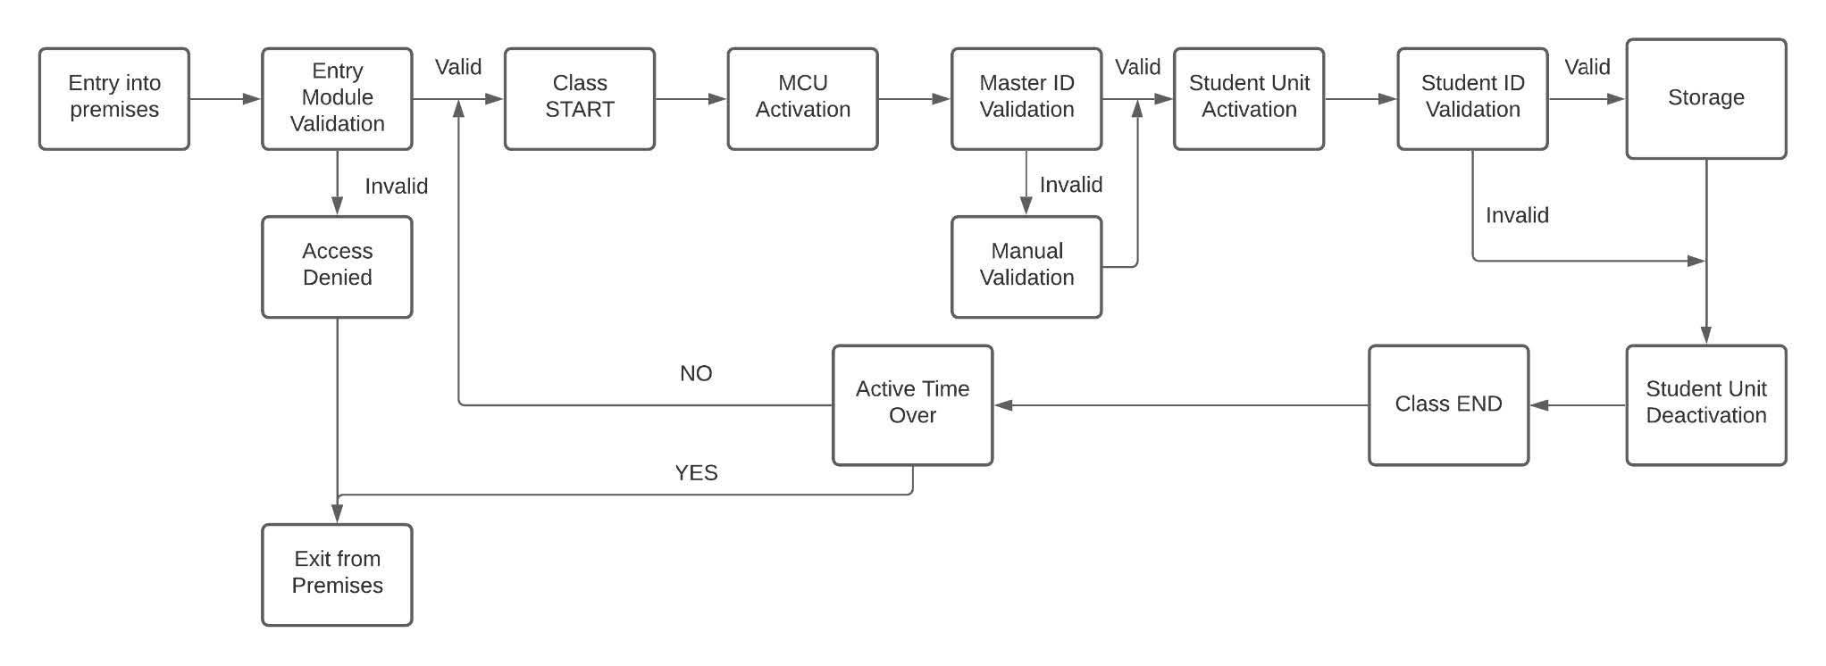

Fig 3.1 Flowchart of the proposed work.

3.2 Arduino Development Board

3.2.1 Arduino Uno : Arduino Uno is a microcontroller board based on the ATmega328P. It has 14 digital input/output pins (of which 6 can be used as PWM outputs), 6 analog inputs, a 16 MHz quartz crystal, a USB connection, a power jack, an ICSP header and a reset button . It contains everything needed to support the microcontroller [11].

3.2.2 Arduino Nano : The Arduino Nano is a small, complete, and breadboard-friendly board based on the ATmega328 (Arduino Nano 3.x). It has more or less the same functionality of the Arduino Uno, but in a different package. It lacks only a DC power jack, and works with a Mini-B USB cable instead of a standard one [11].

3.2.3 Arduino Ethernet Shield : The [Arduino Ethernet Shield 2](https://www.arduino.cc/en/Main/ArduinoEthernetShield) allows an Arduino board to connect to the internet using the [Ethernet library](https://www.arduino.cc/en/Reference/Ethernet) and to read and write an SD card using the [SD library](https://www.arduino.cc/en/Reference/SD). This shield is fully compatible with the former version but relies on the newer W5500 chip. [11]

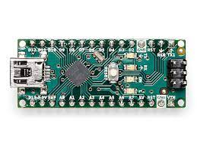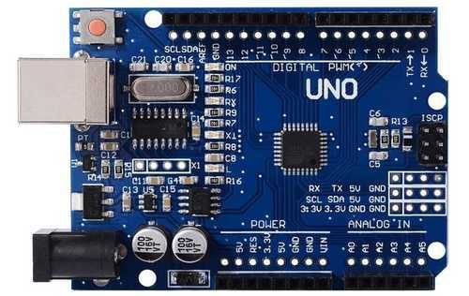Fig.3.2 (a) Arduino Uno, (b)Arduino Nano

3.3 I2C 16x2 LCD

This is a 16x2 LCD display screen with I2C interface. It is able to display 16x2 characters on 2 lines, white characters on blue background. Usually, Arduino LCD display projects will run out of pin resources easily, especially with Arduino Uno. And it is also very complicated with the wire soldering and connection. This I2C 16x2 Arduino LCD Screen is using an I2C communication interface. It means it only needs 4 pins for the LCD display: VCC, GND, SDA, SCL as shown in Fig. 3.3. It will save at least 4 digital/analog pins on Arduino. All connectors are standard XH2.54 (Breadboard type). One can connect with the jumper wire directly. [20]

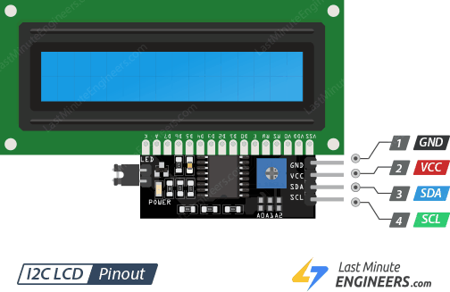

Fig.3.3 I2C 16x2 LCD

3.4 LoRa module (Ai-Thinker Ra-02)

Ra-02 can be used for ultra-long distance spread spectrum communication, and compatible FSK remote modulation and demodulation quickly, to solve the traditional wireless design that cannot take into account the distance, anti-interference and power consumption.

Ra-02 can be widely used in a variety of networking occasions, for automatic metre reading, home building automation, security systems, remote irrigation systems, is the ideal solution for things networking applications.

Ra-02 is available in SMD package and can be used for rapid production by standard SMT equipment. It provides customers with high reliability connection mode. [12]

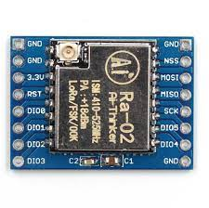

Fig.3.4 LoRa module (Ai-Thinker Ra-02)

3.5 RC522 RFID reader module

This RC522 RFID Card Reader Module 13.56MHz is a low-cost MFRC522 based RFID Reader Module is easy to use and can be used in a wide range of applications. The MFRC522 is a highly integrated reader/writer IC for contactless communication at 13.56 MHz [13]

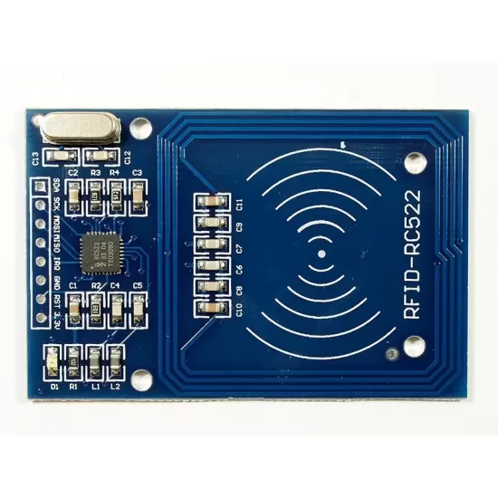

Fig.3.5 RFID-RC522 Reader Module

3.6 Arduino Keypad

The keypad is widely used in many devices such as door lock, ATM, calculator, etc. The keypad is a set of buttons arranged in rows and columns (called matrix). Each button is called a key. Keypad has various types. Two popular types for DIY projects are keypad 3x4 (12 keys) and keypad 4x4 (16 keys). For our project, we will use the 3x4 keypad. Keypad pins are divided into two groups: Rows and Columns. [21]

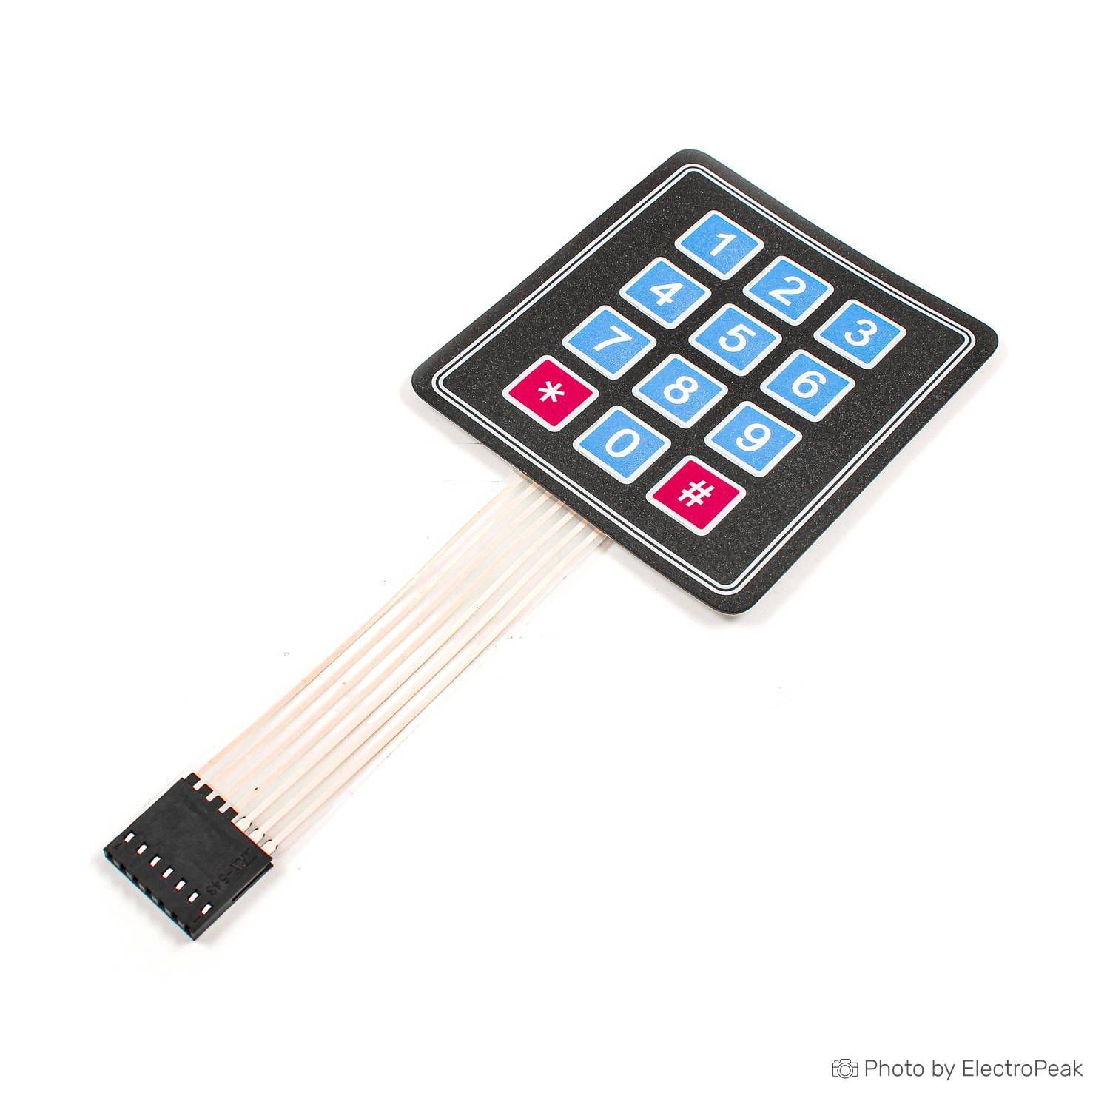

Fig 3.6 Arduino Keypad (3x4).

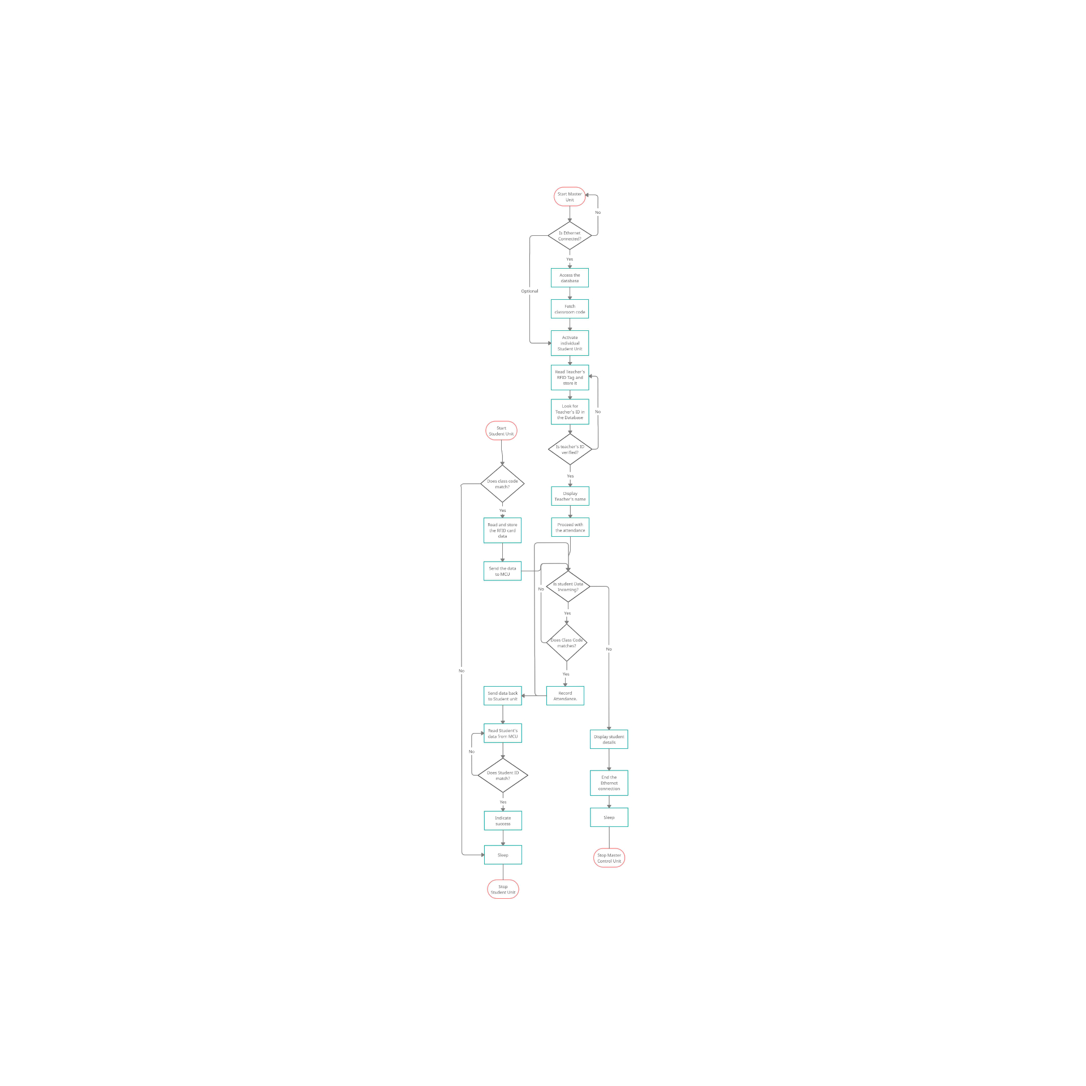 Fig. 4.1 Flowchart of the complete attendance registering process.

In this chapter, we will discuss the Interfacing of Arduino with the RA-02 LoRa module, RC-522 RFID Scanner and I2C LCD. The details of the components used for this project are as follows:

|  |  |  |  |
| --- | --- | --- | --- |
| **Component Name** | **Specification** | **Quantity** | **Price** |
| Arduino Uno | * ATmega328P microcontroller * Input Voltage: 7-12V * DC current per I/O pin: 20mA * DC current for 3.3V pin: 50mA * 14 Digital I/O pins (6 PWM outputs) * 8 Analog Inputs * 32KB Flash Memory * 16MHz Clock Frequency | 1 | 480 |
| Arduino Nano | * ATmega328 microcontroller * Input Voltage: 7-12V * DC current per I/O pin: 40mA * DC current for 3.3V pin: 50mA * 22 Digital I/O pins (6 PWM outputs) * 8 Analog Inputs * 32KB Flash Memory * 16MHz Clock Frequency | 2 | 250 |
| 1602 I2C LCD | * Display: 2-lines x 16-characters * LCD controller: HD44780 * Pin Definition: VCC, GND, SDA, SCL. * Default Address: 0x27 for PCF8574T * Operating Voltage: 5V * Backlight Adjust: Jumper | 1 | 175 |
| RA-02 LoRa module | * Based on SX1278 LoRa chip * Operating Frequency: 433MHz * Input Voltage: 3.3V * Rx current: 93mA * Tx current: 12.15mA * Standby current: 1.6mA * Interface protocol: SPI | 3 | 460 |
| Wires |  |  | 100 |
| RC522 RFID reader | * Based on MFRC522 chip * Read/Write frequency: 13.56MHz * Operating Voltage: 3.3V | 3 | 240 |
| Arduino IDE | * Software for building and debugging Arduino Code used in the Arduino boards |  |  |
| Keypad | * Used for numeric inputs | 1 | 60 |

Table 4.1 Component list and their specifications.

**Interfacing of RC522 RFID reader module with the Arduino UNO/Nano**

Here we will discuss the interfacing of the RC522 RFID reader module with the Arduino UNO/Nano. We have connected these two components as per the image shown below.

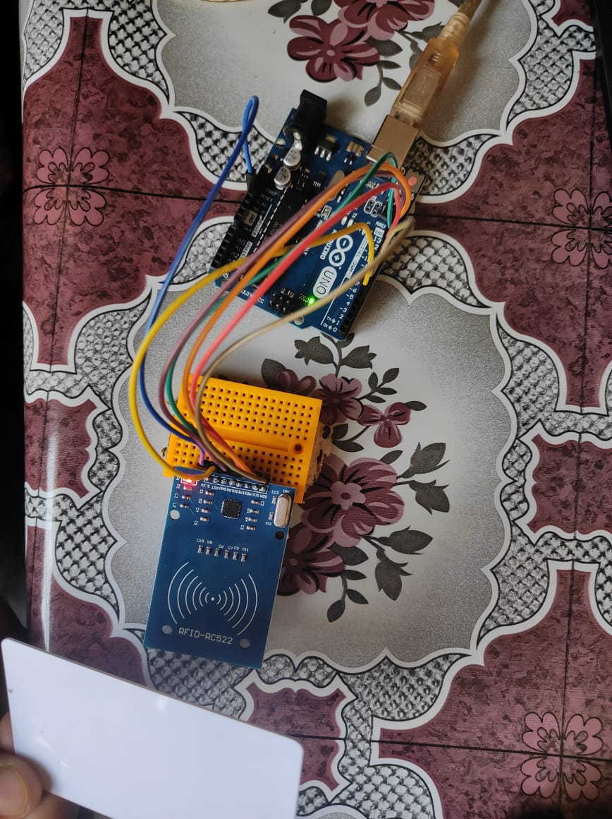

Fig 4.2 Setup of RFID reader with Arduino Uno.

A reader (now more typically referred to as an RFID interrogator) is basically a radio frequency (RF) transmitter and receiver, controlled by a microprocessor or digital signal processor. The reader, using an attached antenna, captures data from tags, then passes the data to the controller for processing. The reader decodes the data encoded in the tags integrated circuit (silicon chip) and the data is passed to the microcontroller for processing.

The 3.3V pin of the RC522 goes to the 3.3V pin of the Arduino UNO/Nano. The GND pin goes to the GND pin of the Arduino UNO/Nano. The MOSI, MISO and SCK pins of the reader connect to the corresponding dedicated MOSI, MISO and SCK pins of the Arduino UNO/Nano i.e. 10 (SS), 11 (MOSI), 12 (MISO), 13 (SCK). The SDA pin of the reader is connected to pin 6 of both the UNO as well as Nano. The RST pin is connected to pin 5 on both as well.

The setup has been used to read the Card Info from the RFID card which is brought near the reader while reading. Here we are using RFID Cards whose IDs we know beforehand. To read the card info, we use the ‘RFID’ library in our Arduino IDE software. Since the RFID reader uses the SPI communication protocol, it also uses the system provided library ‘SPI’.

**Interfacing of LoRa module with the Arduino UNO/Nano**

Here we will be discussing the interfacing of the Arduino Uno/Nano with the Ra-02 LoRa module. The connections with the Arduino Uno/Nano are made as shown below

.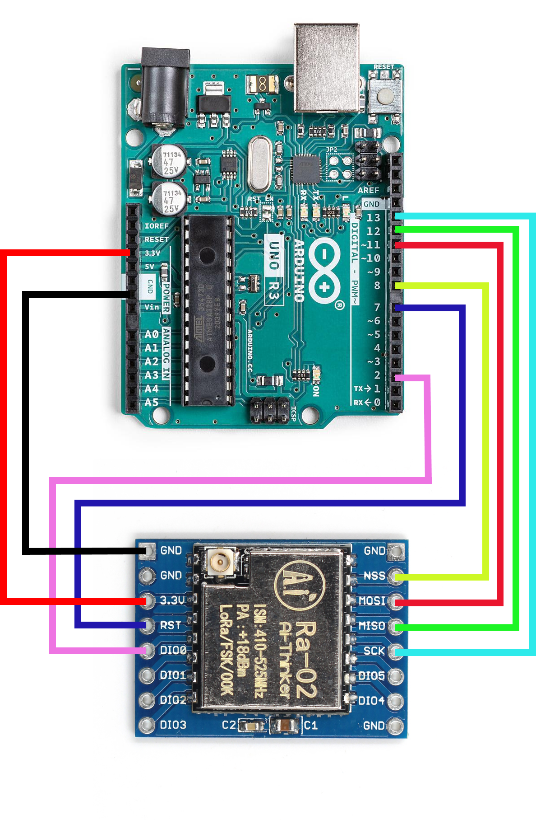

Fig. 4.3 Setup of LoRa with Arduino Uno.

The LoRa module also communicates with the Arduino through SPI communication protocol like the RFID reader and as a result, it utilises the same pins of the Arduino Uno for MISO, MOSI and SCK with the only difference being in the SS and RST pins. The NSS pin of the LoRa module is connected to pin 8 of the Uno/Nano and the RST pin of the LoRa is connected to pin 7 on the Uno/Nano.

This setup of the LoRa module is used to communicate between individual devices through radio. This is partly responsible for activating the Student Units on demand. This is a duplex communication method i.e. it can do both, transmit and receive messages. To utilise the hardware properties of the module, the ‘LoRa’ Library by Sandeep Mistry is used in our project and since it also uses SPI communication, the inbuilt ‘SPI’ library is also used.

**Interfacing I2C LCD with Arduino Uno.**

Here, we will discuss the interfacing of the I2C LCD with the Arduino Uno. The connections have been made as below.

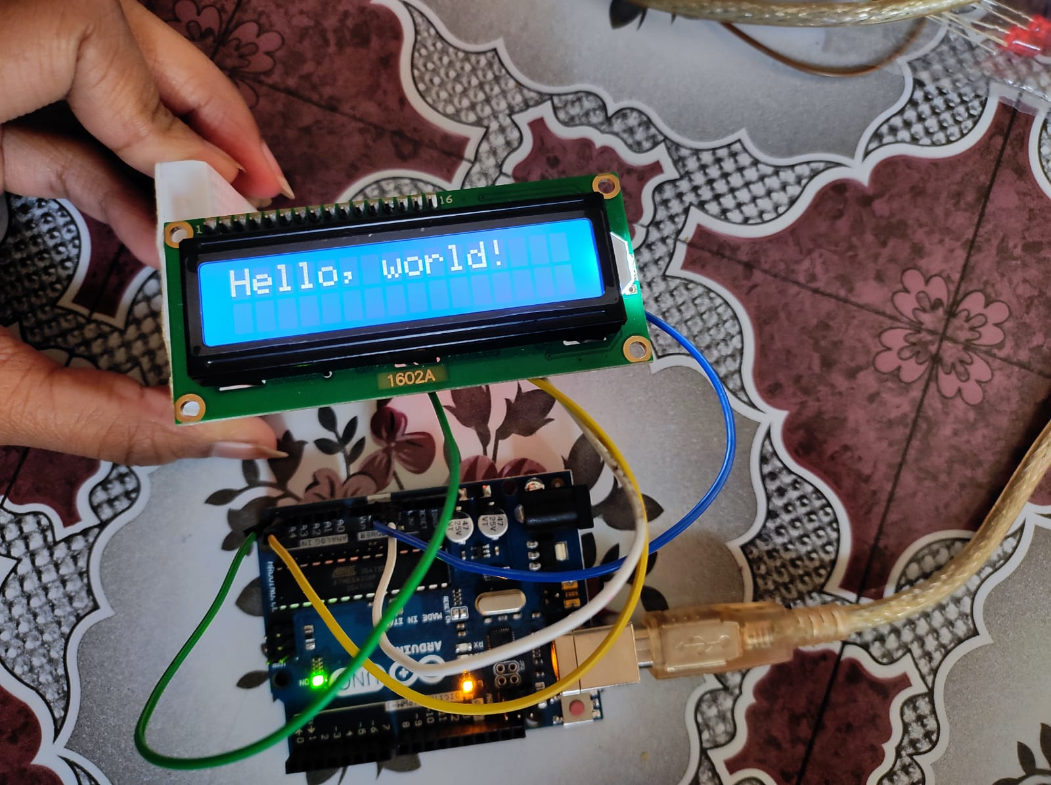

Fig. 4.4 Interfacing of I2C LCD with Arduino Uno.

The display supports 2X16 characters, which means, the LCD can support 2 lines on the display and each line can display 16 characters which is relevant as only the Teacher/Professor’s names are to be displayed and the total number of Students present in the class. Normally, the 1602 LCD works on the SPI protocol but with the help of PCF8574T, we can communicate with the LCD using I2C protocol. When we are using I2C, we are using only two pins, the SDA (Serial Data) and SCL (Serial Clock) which are located on the pins A4 and A5 respectively.

This setup has been used to display necessary information about the process to the teacher/professor currently taking the attendance. It is used for diagnosis, in case of any operational failure. It is used to display the current status of the Attendance registering process. To properly use this 1602 I2C LCD module with the Arduino Uno, we are making use of the ‘LiquidCrystal_I2C’ and ‘Wire’ libraries.

**Structure of the Student Unit**

Out of the components that have been discussed above, the Student Unit mainly comprises the Arduino Nano, RC522 RFID reader module and Ra-02 LoRa module. This is done so as to collect the Information from the student’s ID card when taking the attendance and to transmit that information to the Master Control Unit for further processing. The Setup of the Student Unit is shown below.

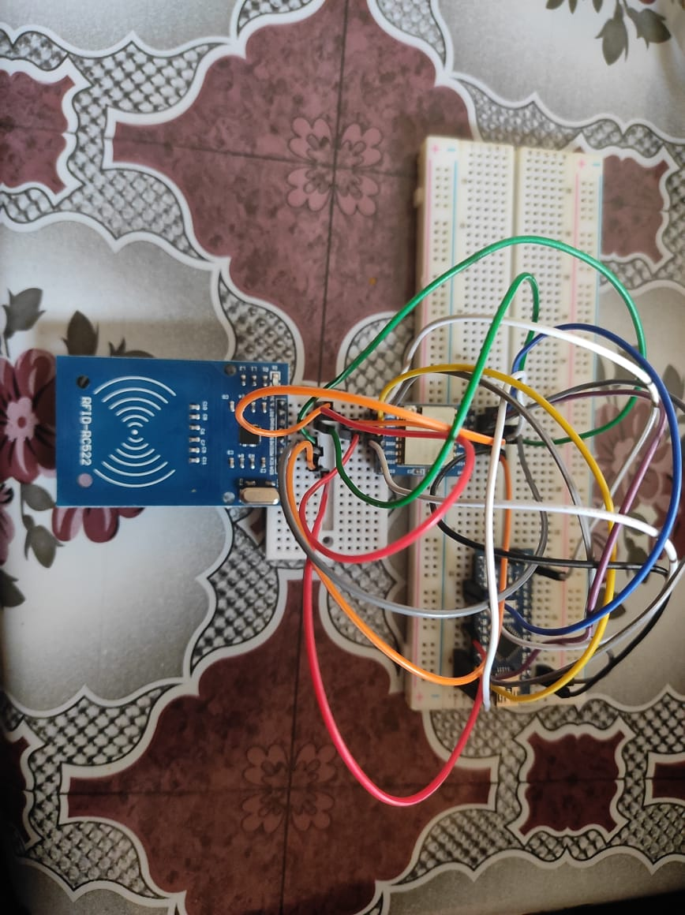

Fig. 4.5 Student Unit.

**Structure of the Master Control Unit**

The Master Control Unit will have an Arduino Uno, RC522 reader module, Ra-02 LoRa module and I2C LCD module. This is done to perform various tasks like reading the teacher’s ID card and verifying the same. Activating the respective Student Units, collecting the information from the Student Units and verifying that the attendance is successfully logged for each student present. The Master Control unit is also capable of displaying any discrepancies in the attendance monitoring process. The Master Control Unit is also responsible for establishing internet connectivity with the database and communicating with the database. The Setup of the Master Control Unit is shown below.

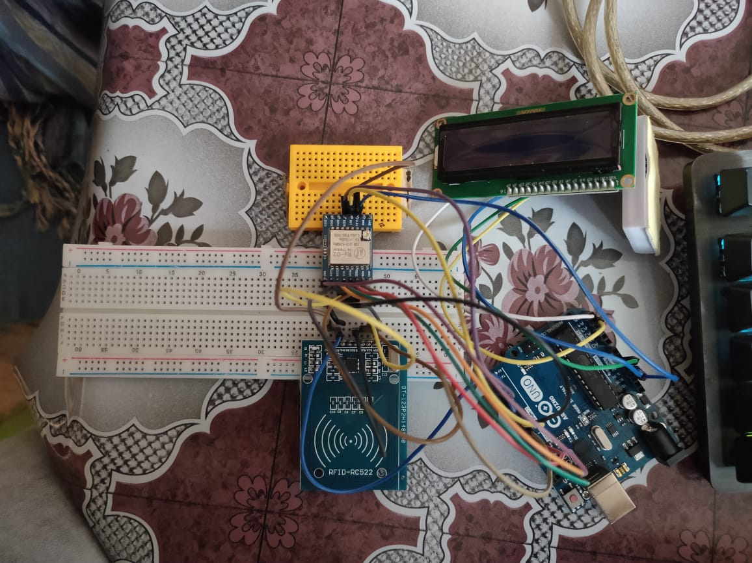 Fig. 4.6 Master Control Unit.



Fig. 4.7 Image depicting the Master Control Unit on the teacher’s dais (Yellow) and multiple Student Units present at each Desk (Blue).

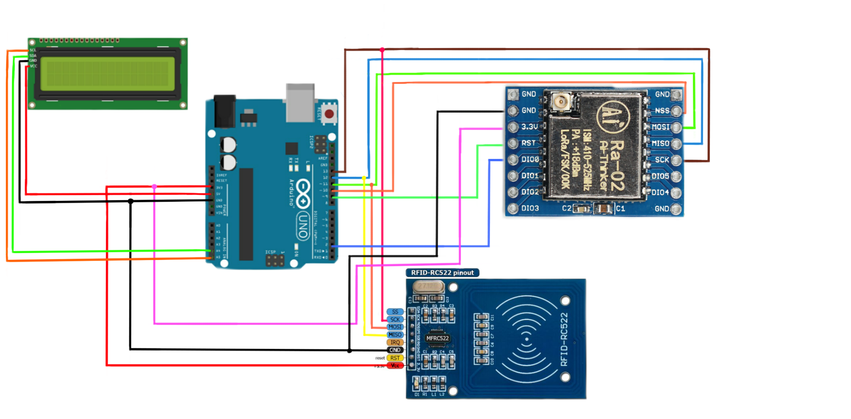

Fig. 4.8 Complete Circuit diagram of the Master Control Unit.

**5. Result/Performance Analysis**

In this chapter, we are going to discuss the testing results that we have got while performing the performance analysis of our system.

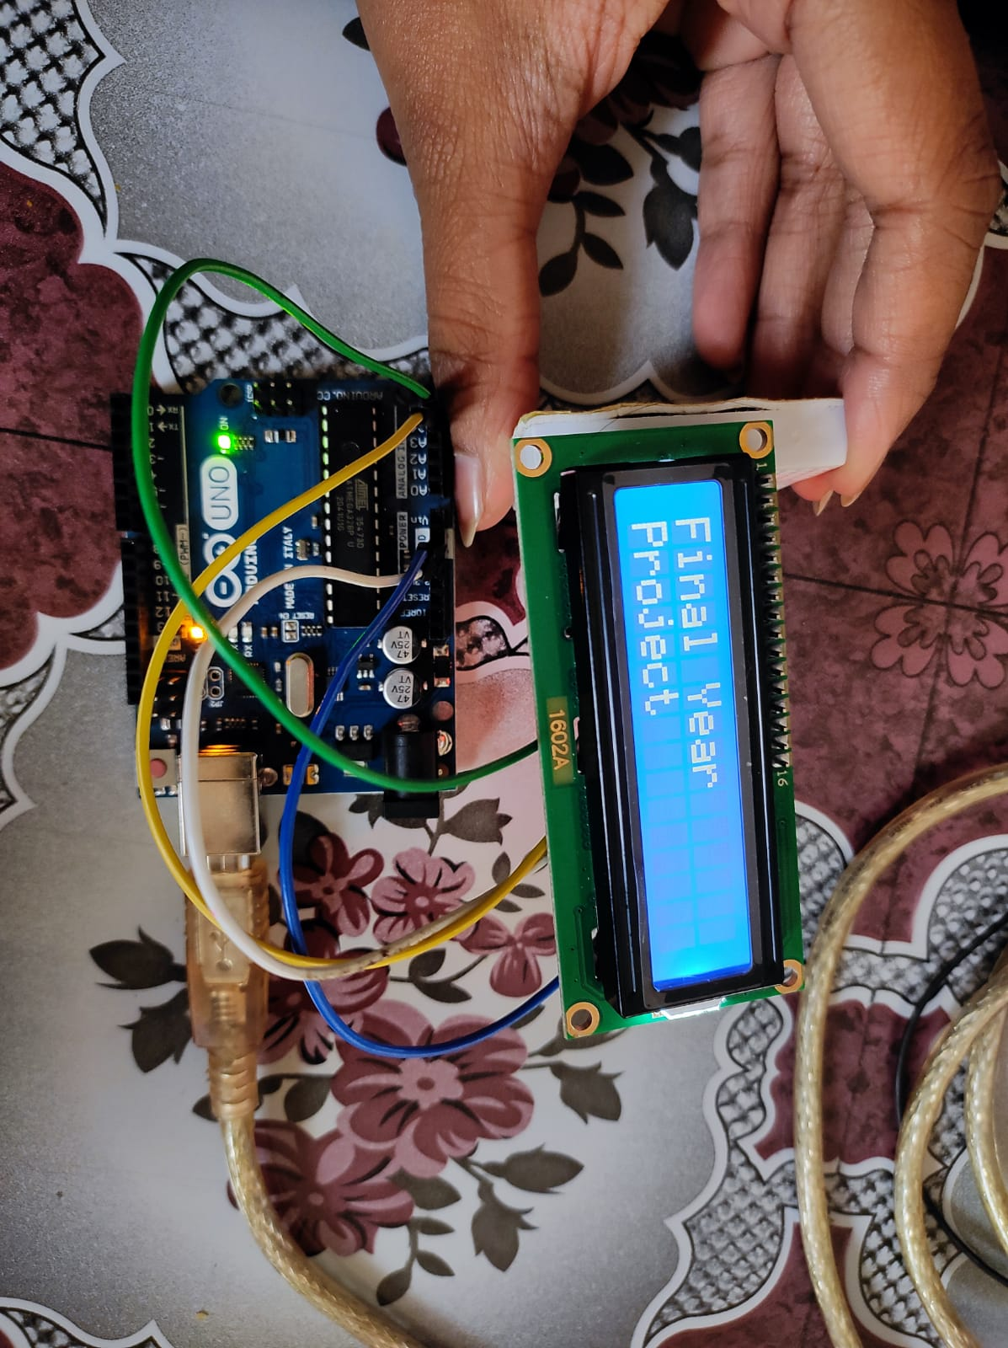First, we verify that we are able to show the required information on the LCD display as is necessary. We changed the Text from the initial “Hello World” to “Final Year Project” spanning over the entire display. Since the display can show only 16 characters on a line, the first two words were in the first line and the last word was placed on the second line. The result is shown below.

Fig. 5.1 LCD displaying the text “Final Year Project”.

Then we verify that the RFID reader is successfully able to detect, read and transfer the data to the Arduino Uno/Nano. For this, we make the necessary setup and bring an ID card near twice to double check the input data. The result is shown below.

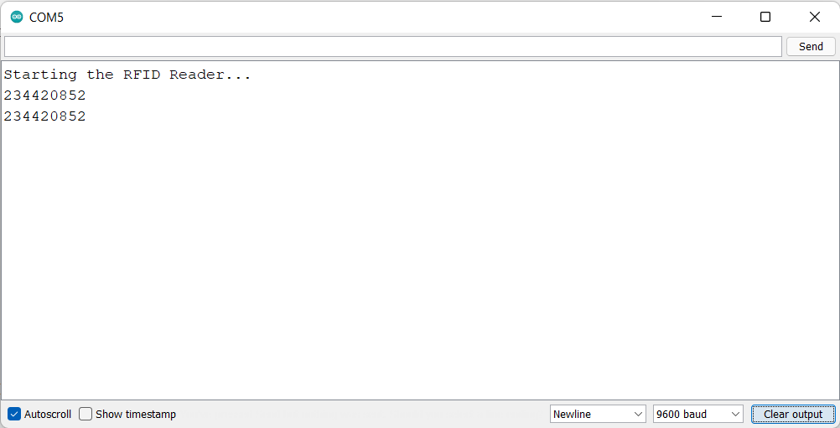Fig. 5.2 RFID reader reading the data from the Card and transferring that data to the Uno.

Next, we verify that the LoRa module is operating properly and that it is able to receive multiple signals simultaneously without losing any information. It is necessary to be able to do this so that the attendance registering process is smooth and reliable. Two Student units transferred data to the Master Control Unit simultaneously at an interval of 0.5 secs and the MCU was able to detect all signals without any losses. The result is shown below.

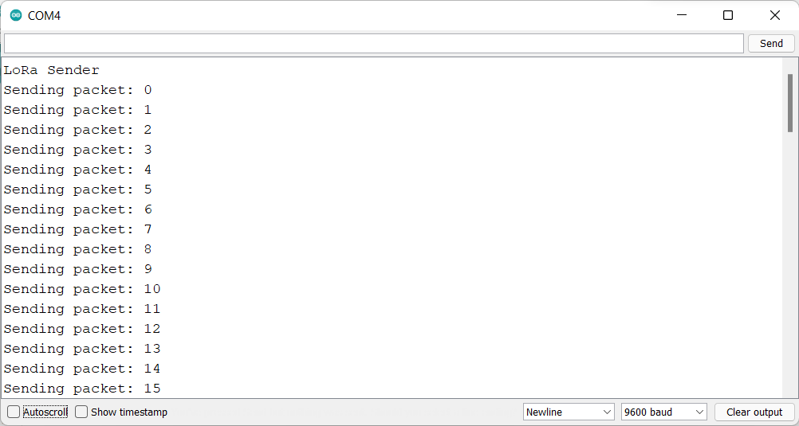

Fig. 5.3 One of the Student Units sending data to the MCU.

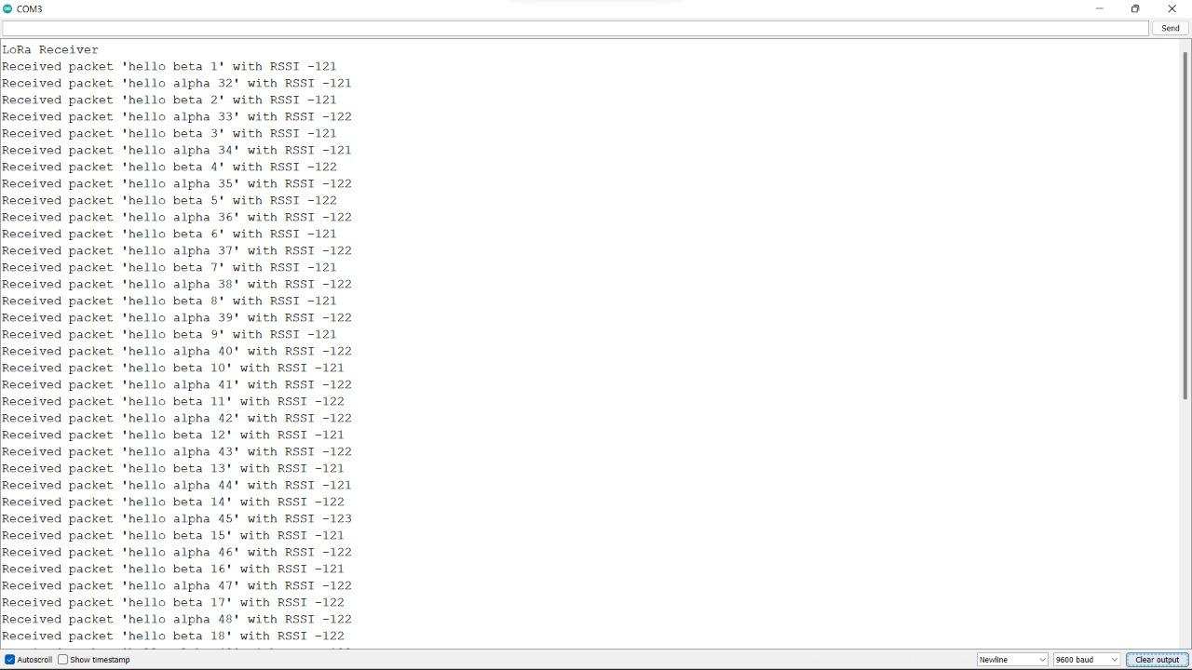

Fig. 5.4 Output of MCU receiving data from both the SUs without any loss.

Individual components were tested in their capacity and found to be able to fulfil their needs.

**6. Future Work and Conclusion**

Our project will put a positive impact in the following domains,-

* This project can be tweaked to accommodate the needs of other organisations or institutions that do not maintain or follow the similar structure of attendance monitoring.
* Various other methods can be integrated and/or changed to respond to various demands that were not met in this project. For example, Biometric verification can be done at each SUs at the cost of expense and complexity.
* As the RFID technology evolves, more sophisticated applications will use the capability of RFID to receive, store and forward data to a remote sink source.
* RFID has as many applications as can be imagined. In this project, we have utilised the versatility of RFID in implementing a functional and automatic student attendance recording system that allows students to simply fill their attendance just by placing their RFID cards over the RFID reader which are located at the desk of every student.

We hope that this system can shift the paradigm of students’ lecture attendance monitoring in face-to-face classroom and provide a new, accurate, and less cumbersome way of taking student attendance.

**References**

[1] Gatsheni, B.N., R.B. Kuriakose, and F. Aghdasi. *Automating student class attendance register using radio frequency identification* in South Africa, in Mechatronics, ICM2007 4th IEEE International Conference in 2007.

[2] Mahyidin, M.F. *Student Attendance Using RFID System* 2008; Available from: [http://umpir.ump.edu.my](http://umpir.ump.edu.my/).

[3] G.C. Onuniwu, G.N. Okorafor. *Radio Frequency Identification (RFID) Attendance System With Automatic Door Unit*. Academic Research International, Vol. 2, No. 2, March 2012. ISSN-L: 2223-9553, ISSN: 2223-9944

[4] T. S. Lim, S.C. Sim, M. M Mansor. *RFID Based Attendance System*. 2009 IEEE Symposium on Industrial Electronics and Applications (ISIEA 2009), Kuala Lumpur, Malaysia, October 4-6, 2009.

[5] Murizah K, Hasbulla M,Norliza Z, Muhammad K.S. *Web-based student attendance system using RFID technology.* [2012 IEEE Control and System Graduate Research Colloquium](https://ieeexplore.ieee.org/xpl/conhome/6269158/proceeding), Shah Alam, Malaysia, July 16-17, 2012.

[6] Ravishankar Yadav, Sumita Nainan *Design of RFID Based Student Attendance System with Notification to Parents Using GSM.* International Journal of Engineering Research & Technology (IJERT) Vol. 3 Issue 2, February - 2014. ISSN: 2278-0181.

[7] Hasan U.Z, Jannatul S.H, Tasnim T.A, Deboshree C. *RFID based attendance system.* [2017 8th International Conference on Computing, Communication and Networking Technologies (ICCCNT)](https://ieeexplore.ieee.org/xpl/conhome/8123903/proceeding), July 3-5, 2017.

[8] Semtech. *Lora Modulation Basics.* [online]. Available from: <https://semtech.my.salesforce.com/sfc/p/E0000000JelG/a/2R0000001OJu/xvKUc5w9yjG1q5Pb2IIkpolW54YYqGb.frOZ7HQBcRc?__hstc=212684107.de2f0de5dcb38e6e4f13de8a16269d24.1635683594114.1635768178532.1638474463795.3&__hssc=212684107.3.1638474463795&__hsfp=263881901>. [Accessed 18/02/2021].

[9] L. Sandip, “RFID Sourcebook”, IBM Press, USA, (2005)ISBN: 0-13-185137-3

[10] Radio-frequency identification. Wikipedia (online). Wikimedia Foundation, Inc., 2009.

[11] Arduino Uno/Nano/ Ethernet Shield. Arduino.cc. Available from: <https://store-usa.arduino.cc/collections/boards> [Accessed on: December 4, 2021].

[12] Ra-02 LoRa module. Ai-Thinker.com [online]. Available from: <https://docs.ai-thinker.com/_media/lora/docs/c048ps01a1_ra-02_product_specification_v1.1.pdf>. [Accessed: November 10, 2021].

[13] RC522 RFID reader module. Robu.in [online]. Available from: <https://robu.in/product/rc522-rfid-card-reader-module-13-56mhz/>. [Accessed: 4 December,2021].

[14] R307 Fingerprint Module.Robu.in [online].Available from: <https://robu.in/product/r307-optical-fingerprint-reader-module-sensor/>.[Accessed: 4 December,2021].

[15] Fingerprint Sensor R307. Sunrom.com [online].Available from: <https://www.sunrom.com/p/finger-print-sensor-r307-new-r305>. [Accessed: 4 December,2021].

[16] PHP Tutorial. javaTpoint.com . [online]. Available from: <https://www.javatpoint.com/php-tutorial>. [Accessed: December 4. 2021]

[17] MySQL. Wikipedia [online]. Wikimedia Foundation, Inc., 2009.

[18] LoRa. Wikipedia. [online]. Wikimedia Foundation, Inc., 2009.

[19] Lora PHY. Semtech [online]. Available from: <https://www.semtech.com/lora/what-is-lora>. [Accessed: March 2, 2021].

[20] I2C 16x2 Arduino LCD Display Module. Dfrobots.com [online]. Available from: https://www.dfrobot.com/product-135.html. [Accessed: December 4, 2021].

[21] Arduino Keypad. Arduinogetstarted.com [online]. Available from: https://arduinogetstarted.com/tutorials/arduino-keypad. [Accessed: 01.02.2022]

**Appendix**

RFID - Radio Frequency Identification

LCD - Liquid Crystal Display

LoRa - Long Range

MCU - Master Control Unit

SU - Student Unit

I2C - Inter Integrated Circuit

SPI - Serial Peripheral Interface

MOSI -Master Out Slave In

MISO - Master In Slave Out

SCK - Serial Clock

SS - Slave Select

RST - Reset

UART - Universal Asynchronous Receiver-Transmitter

IC - Integrated Circuit